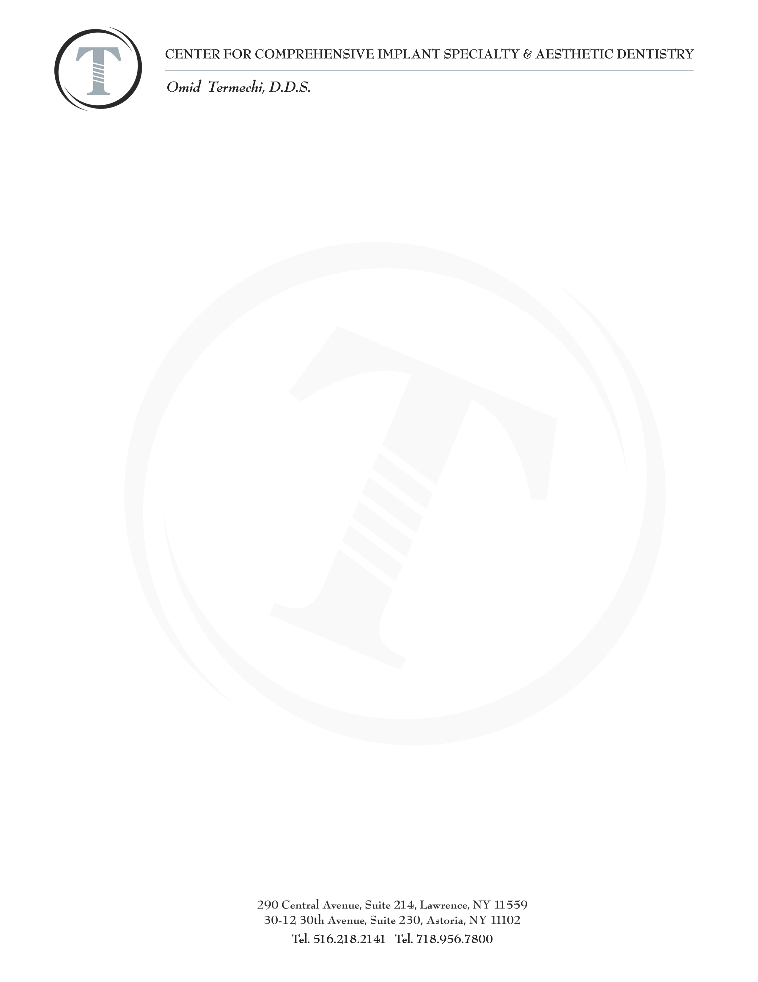
Post Operative Instructions

Please read instructions carefully. If you have any questions or in case of emergency
please call 718-956-7800.

Take medications as instructed.

For the first 24 hours place icepack on face in ten minute intervals, ten minutes on, ten minutes off.
Frozen peas work very well. Not necessary to use ice pack the following day.

Do not use a straw to drink.
Do not spit.
Do not blow your nose forcefully if you have had sinus surgery
Do not eat hot foods or liquids the day of the surgery for the rest of the day.
Do not smoke. Try substituting with a patch.
Avoid strenuous exercise and heavy lifting for one week, two weeks if you have had sinus surgery

While your implants heal, avoid hard foods even if you want to chew on other side.Example:
Pretzels, bagels, bones, hard candy, seeds, nuts etc.
You will need to be on a soft diet from the day of the surgery to the end of the week. Example:
- scrambled eggs, mashed potatoes, yogurt, soup, oatmeal, ice-cream, applesauce, bananas, pasta, tuna; anything you can cut with your fork.

Beginning the day after surgery rinse with warm salt water. 8 oz of water 1/2 teaspoon of salt.
4-6 times a day for 5 days.
Gently rinse with Listerine or Peridex the day after the surgery then do not eat or drink for 30 minutes.
2nd week gently swab surgical area with Listerine or Peridex using a Q-Tip

You may want to place a towel on your pillow for several nights after the surgery so you can protect your linen from blood due to drooling.

For smokers: If you are a smoker, a failed implant will be replaced at cost the first time.
If it fails a second time Implant will be replaced at full price.

Please note that all surgical appointments cancelled without a 72 hour notice is subject to a $500 non refundable cancellation fee.

